the vba of wall street

Assignment # 2

BCS – Excel (VBA)

Jose Luis Bracho

VBA of Wall Street Project

Background:

You are well on your way to becoming a programmer and Excel master! In this homework assignment you will use VBA scripting to analyze real stock market data. Depending on your comfort level with VBA, choose your assignment from Easy, Moderate, or Hard below.

Requested:

Stock market analyst

***Easy***

Create a script that will loop through one year of stock data for each run and return the total volume each stock had over that year.

You will also need to display the ticker symbol to coincide with the total stock volume.

***Moderate***

Create a script that will loop through all the stocks for one year for each run and take the following information.

* The ticker symbol.
* Yearly change from opening price at the beginning of a given year to the closing price at the end of that year.
* The percent change from opening price at the beginning of a given year to the closing price at the end of that year.
* The total stock volume of the stock.

You should also have conditional formatting that will highlight positive change in green and negative change in red.

***Hard***

Your solution will include everything from the moderate challenge.

Your solution will also be able to return the stock with the "Greatest % increase", "Greatest % Decrease" and "Greatest total volume".

***CHALLENGE***

Make the appropriate adjustments to your script that will allow it to run on every worksheet, i.e., every year, just by running it once.

This can be applied to any of the difficulties

Results

Two main files are uploaded to GitHub:

* Module1.bas : This file shows the loops used to calculated de yearly change for each stock and in the same way, maximum stock volume and the minimum and maximum change among all the stocks.
* Formulario.frm : In order to make the calculations for all the sheets (years) at once, a GUI was created which allow the user to select one or more desired sheets.
* Formulario.frx : This file contains machine code that represents the GUI design itself.

Figures:

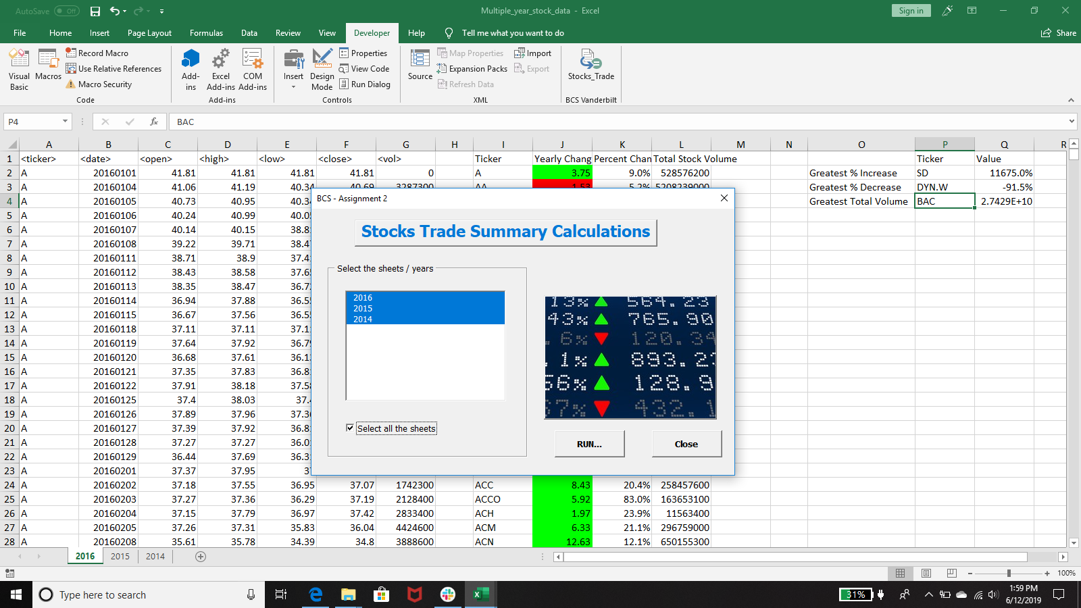

Figure 1. Example of summary calculations for a stock market in year 2016.